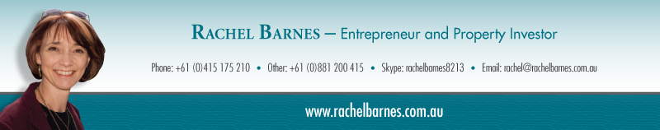
How to Become an Investor Friendly Agent
Knowing your customer is important and that’s just one good reason for having an experienced Property Buying Customer share her knowledge and experience with you over a half day workshop. Let me tell you a little about her background so you understand why the information she’ll share is worth listening too.
Rachel Barnes spent 20 years in the finance industry, working her way up from a casual loans typist to become the first female Executive Manager of a leading Credit Union. Rachel and her partner John Fowler, realized their goal of leaving the corporate world over 10 years ago. It wasn’t through luck – it was through Property Investing.
Their ‘claim to fame’ was their speed of purchasing 75 rentals in just 64 months. That gave them the opportunity to travel extensively – in fact they have had the good fortune to visit over 20 countries in the past 10 years, as well as investing in some of them. Investing overseas has helped them appreciate the benefits of investing in Australia, where you can work with Professionals in the industry.
Rachel also has a background in traditional business, as well as non-traditional business. She has co-authored 5 books relating to property and business, as well as being interviewed on Today Tonight, A Current Affair, and on Radio shows such as ‘Real Estate Talk’ in Brisbane.
She has been featured in and provided content for newspapers and magazines many times including Australian Property Investor magazine, Your Investment Property magazine an NZ Property Investor.
Over the past 7 years Rachel has travelled nationally and internationally with ‘Property Women’ as a presenter helping to inform, educate and empower women to invest in property. She also personally mentors men and women in property investing. In addition, Rachel been a guest speaker at other events such as TAFE (Property School), Westpac Women’s network, as well as other local property investor groups, and is one of leaders and presenters of a $400m Coffee company that she’s helping to expand globally…. You may even get to sample some of that product too!
In summary, Rachel will share her many years of property investing experience, tips, techniques and tools with you and your team to help each of you be even more successful in your Real Estate career.
“Rachel is an eloquent and informative speaker and she has added a huge amount of value to our team. Great content Rachel!” Valerie Timms (Timms Real Estate Proprietor - Aug 2014)
“Well done Rachel, a fantastic informative presentation on property investment. Very friendly, kind and thoughtful.” Jason Mills (Sales Agent)
“As someone new to Real Estate Sales I appreciated the information in simple terms. Thank you.” Caterina D

